**INTERNAL MAIL SERVER**

INTRODUCTION:

Mail server (or email server) is a computer system that sends and receives email using standard email protocols. A mail server is a server that handles and delivers e-mail over a network, usually over the Internet. A mail server can receive e-mails from client computers and deliver them to other mail servers. A mail server can also deliver e-mails to client computers. A client computer is normally the computer where you read your e-mails, for example your computer at home or in your office. Also an advanced mobile phone or Smartphone, with e-mail capabilities, can be regarded as a client computer in these circumstances.

There are two types of mail servers.They are SMTP and POP3.**SMTP** is an acronym for **Simple Mail Transfer Protocol** and it is a protocol that is used when e-mails are delivered from clients to servers and from servers to other servers. When you download e-mails to your e-mail program the program will connect to a server on the net that is known as a POP3 server. A POP3 server uses a protocol named POP3 for its communication. That is the reason why it is called a POP3 server and **POP3** is an acronym for **Post Office Protocol** version **3**.

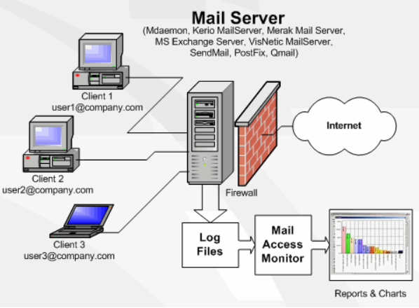

WHAT IS INTERNAL MAIL SERVER?

* An internal mail server is an application that receives incoming email from local users (people with in the same domain) and remote senders and forwards outgoing email for delivery.
* A computer dedicated to running such applications is also called a mail server. Microsoft exchange, Gmail, Exim and sendmail are among the more common mail server programs.
* If a particular customer need to have his/her own domain name to the email address/ addresses, customer should have the Mail Server facility.

HOW MAIL SERVER WORKS?

* The mail server works in conjunction with other programs to make up what is sometimes referred to as messaging system.
* As a rule, the system uses SMTP (Simple mail Transfer Protocol) or ESMTP (extended SMTP) for sending e-mail, and either POP3 (Post Office Protocol 3) or IMAP (Internet Message Access Protocol) for receiving e-mails.

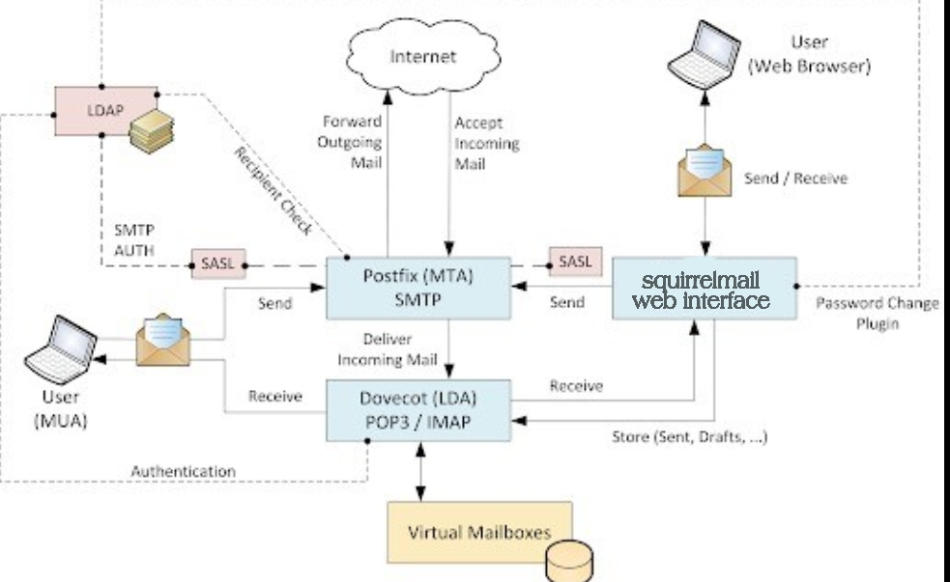

SETTING UP AND CONFIGURING A LINUX MAIL SERVER:

Setting up Linux mail server and SMTP (Simple Mail Transfer Protocol) is essential if you want to use email, so we’re going to install and configure mail server along with some other email-related protocols, like Post Office Protocol (POP3) and Internet Message Access Protocol (IMAP).

Step:1. Remove default MTA sendmail

Sendmail is a program that runs on most servers. Sendmail provides mail-transfer and delivery methods, including the Simple Mail Transfer Protocol (SMTP). However, it is not necessary to have this sendmail. For those who plan to install postfix as an alternative, the can just uninstall the sendmail service to avoid port conflict during installation. In this post i will show you the simple steps to remove sendmail service

#yum remove sendmail

Step:2. Add hostname entries in /etc/hosts file as shown below:

“*vi /etc/hosts*”

Add the following:

192.168.216.131 mail.aditya.rh mail

Step:3. Disabled selinux

RedHat turns SELinux on by default because its safer. Nearly every vendor that uses Redhat-derived products turns SELinux *off* because they don't want to have to put in the time (and therefore money) to figure out why the thing doesn't work. The Redhat/Fedora people have put in a massive amount of time and effort making SELinux more of a viable option in the Enterprise, but not a lot of other organizations really care about *your* security.

“*vi /etc/sysconfig/selinux*”

Change SELINUX=enforcing to SELINUX=disabled.

SELINUX=disabled

4. Install EPEL Repository:

(EPEL- EXTRA PACKAGES FOR ENTERPRISE LINUX)

The EPEL repository is an additional package repository that provides easy access to install packages for commonly used software.

“*yum install epel-release*”

5. Allow the Apache default port 80 through your firewall/router:

“*firewall-cmd --permanent --add-port=80/tcp*”

Restart firewall using command:

“*firewall-cmd –reload*”

Restart your server to take effect all changes.

6. Install Postfix

Postfix is an MTA (Mail Transfer Agent), an application used to send and receive email. In this, we will install and configure Postfix so that it can be used to send emails by local applications only.

“*yum install postfix*”

Configuring PostFix

*“vi /etc/postfix/main.cf”*

## Line no 76 - Uncomment and set your mail server FQDN ##

myhostname = mail.aditya.rh

## Line 83 - Uncomment and Set domain name ##

mydomain = aditya.rh

## Line 99 - Uncomment ##

myorigin = $mydomain

## Line 113 - Uncomment and Set ipv4 ##

inet_interfaces = all

## Line 119 - Change to all ##

inet_protocols = all

## Line 164 - Comment ##

#mydestination = $myhostname, localhost.$mydomain, localhost,

## Line 166 - Uncomment ##

mydestination = $myhostname, localhost.$mydomain, localhost, $mydomain

## Line 264 - Uncomment and add IP range ##

mynetworks = 192.168.216.0/24, 127.0.0.0/8

## Line 419 - Uncomment ##

home_mailbox = Maildir/

Save and exit the file.

Start/restart Postfix service now:

“*systemctl enable postfix”*

*“systemctl restart postfix*”

Test the Postfix Server

#useradd abc

#passwd abc

6. Install and Configure Dovecot

Dovecot is an open source IMAP and POP3 server for Linux/UNIX-like systems, written with security primarily in mind. Dovecot is an excellent choice for both small and large installations. It's fast, simple to set up, requires no special administration and it uses very little memory.

“*yum install dovecot*”

The following list is some of the parameters used to configure dovecot

*“vi /etc/dovecot/dovecot.conf”*

## Line 24 - uncomment ##

protocols = imap pop3 lmtp

“*vi /etc/dovecot/conf.d/10-mail.conf*”

## Line 24 - uncomment ##

mail_location = maildir:~/Maildir

*“vi /etc/dovecot/conf.d/10-auth.conf”*And make the changes as shown below:

## line 10 - uncomment##

disable_plaintext_auth = yes

## Line 100 - Add the word: "login" ##

auth_mechanisms = plain login

*“vi /etc/dovecot/conf.d/10-master.conf”*

Make changes as shown below:

## Line 91, 92 - Uncomment and add "postfix"

#mode = 0600

user = postfix

group = postfix

[...]

Start Dovecot service:

*“systemctl enable dovecot”*

*“systemctl start dovecot”*

8. Installing and Configuring Squirrelmail:

squirrelmail is an interface to your organization's email system through the web. It has all the functionality you would want from an email client, including strong support for attachments, address books, calendar and folders. Squirrelmail is also highly customizable.

Squirrelmail is a standards-based webmail package written in PHP. It includes built-in pure PHP support for the IMAP and SMTP protocols, and all pages render in pure HTML 4.0 (with no JavaScript required) for maximum compatibility across browsers. It has few requirements and is easy to configure and install.

*“yum install squirrelmail”*

*“cd /usr/share/squirrelmail/config/”*

*“./conf.pl”*

Enter 1 for organisational preferences

Enter 1 and change the organization Name(aditya.rh)

Press S

Press R for previous menu

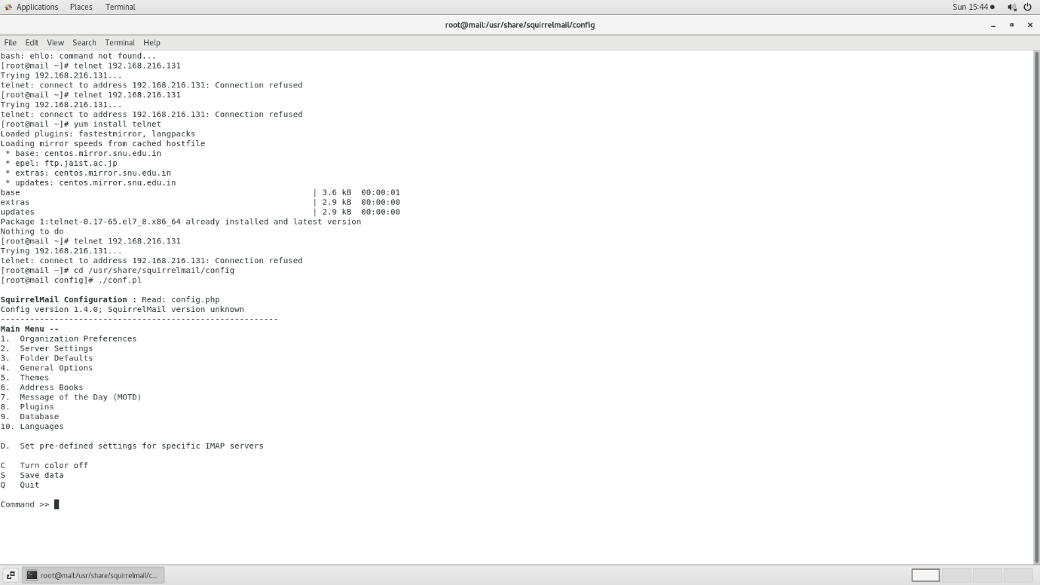

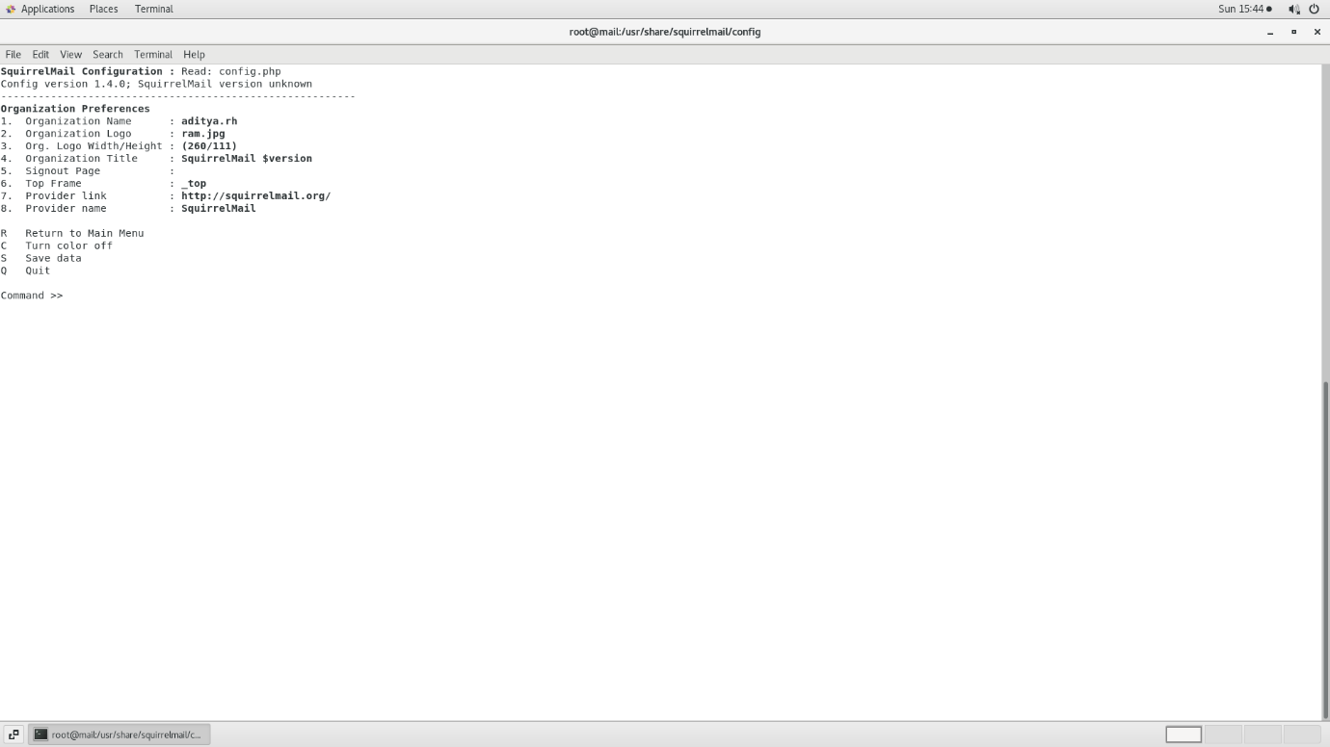Enter 2 for Server settings

Press 1

and type: mail. (Name of Domain)(aditya.rh)

Press3

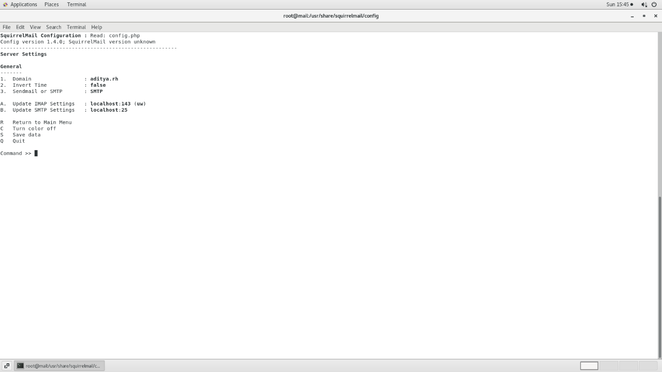

Press 2 for switching from Send Mail to SMTP

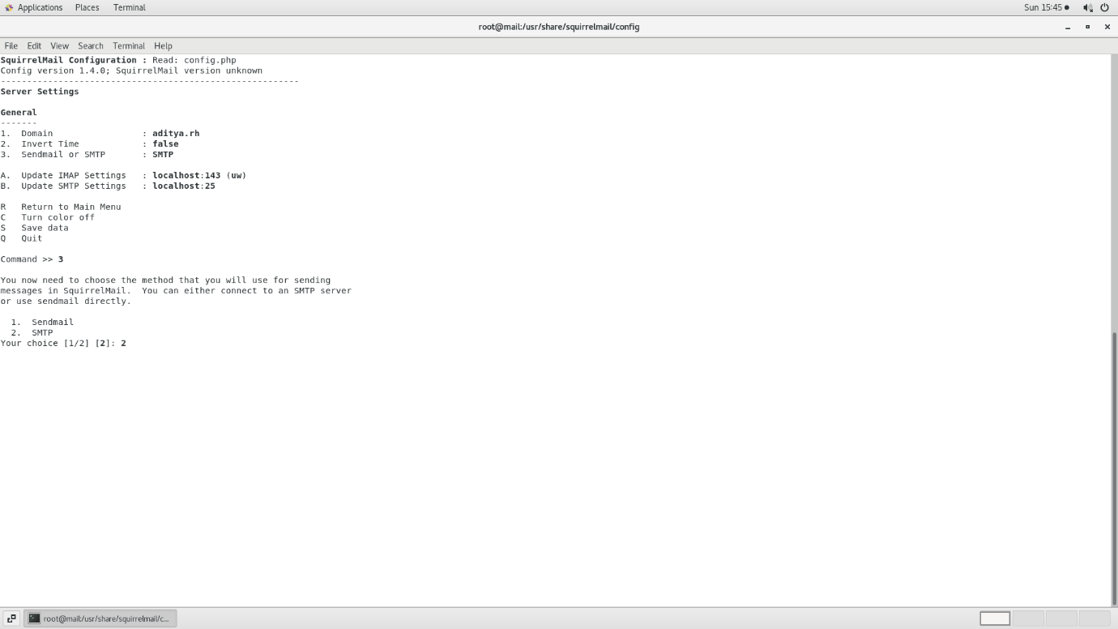

Type S and Press Q for quit

9.Install httpd (HYPER TEXT TRANSFER PROTOCOL DAEMON)

Hypertext transfer protocol daemon, a Unix web server that is able to handle HTTP and HTTPS requests.

“*yum install httpd*”

Create a squirrelmail host in apache config file:

“*vi /etc/httpd/conf/httpd.conf*”

Enter the following:

Alias /webmail /usr/share/squirrelmail

<Directory /usr/share/squirrelmail>

Options Indexes FollowSymLinks

RewriteEngine On

AllowOverride All

DirectoryIndex index.php

Order allow,deny

Allow from all

</Directory>

Start the httpd service:

*“systemctl enable httpd”*

*“systemctl restart httpd”*

10.Add Clients

1. “useradd user1”

Create a password for user1

“passwd user1”

1. “useradd user2

Create a password for user2

“passwd user2”

Enter the following command:

“*setsebool httpd_can_network_connect=1*”

11.Final step (Entering into webmail)

[*http://ipaddress/webmail*](http://ipaddress/webmail)

FUTURE ENHANCEMENT:

For future work we redefine our techniques in order to get more valuable and accurate outputs useful for instructors to improve the students learning outcomes.

We want to enhance **Gmail interface** to send and receive emails using an email account you create with your domain. By setting up your domain’s email address as a **POP3** and **SMTP** account in your Gmail account, you can use Gmail as an email client much like you would use Outlook, Mac Mail, or Thunderbird.

Conclusion:

In this article, we created an Internal Mail Sever in linux and we have seen how to send and receive emails from local users and remote senders and forwards outgoing email for delivery.